OOP WEEK 5

DATABASE LAB

PADDY DOWNEY

G00392495

1.

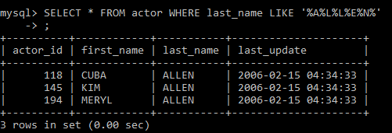

2.

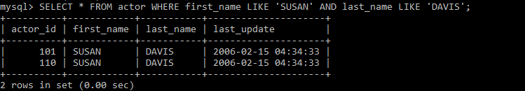

3.

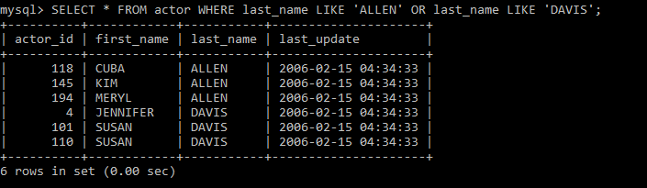

4.

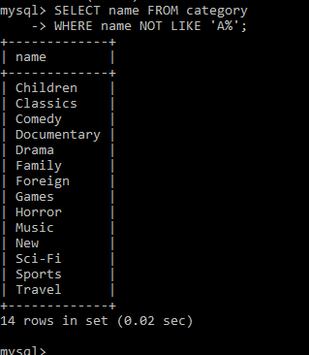

5.

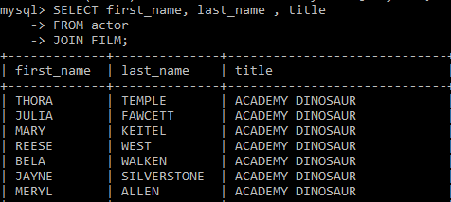

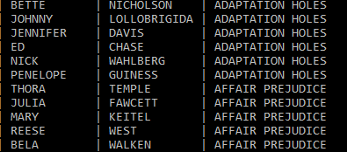

6.

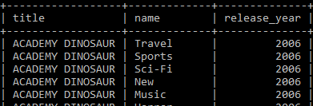

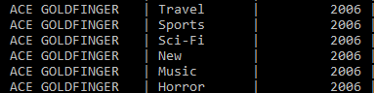

7.

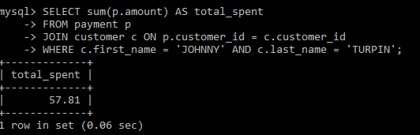

8.

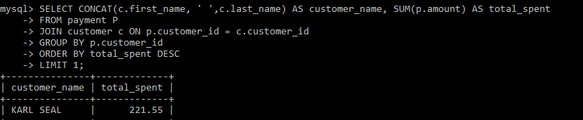

9.

10.

